To:

Mr Gerard McPhee

10 McCubbin Street

Kew East, Victoria, 3102

**Regarding;**

**Opinion and evidence relating to suspected corrupt conduct by public officials and others engaged in the approval of planning application 2008/0980 as follows;**

**“Alpine Resorts Planning Scheme**

**Permit Application no. 2008/0980**

**Buildings and works associated with the construction of a road**

**(Mt. Buller – Mt. Stirling Link Road) and the removal of vegetation including native vegetation, Mt. Buller and Mt. Stirling Alpine Resorts.”**

Dear Gerard,

**Introduction**

All of what appears below is my personal opinion. It is not intended to represent the views of any other person or organisation. You are welcome to submit this letter to any authority, as you see fit. I am happy to co-operate and contribute to the investigations of any authority that may inquire into the matters mentioned here.

In relation to the Planning Application 2008/0980 mentioned above, I have been concerned about a perception of “corrupt conduct” by public officials and others, as defined in Part 1 Section 4 of the Independent Broad-based Anti-corruption Commission Act, 2011.

**Suspicion of corrupt conduct**

I have formed the firm view that the real reason for constructing a new short road across Corn Hill is to complement the construction of accommodation and other infrastructure on Mount Stirling. Mount Stirling would then act as a dormitory suburb of Mount Buller, with connecting bus services via the new Link Road. Construction of accommodation and related infrastructure on Mount Stirling is currently prohibited under Section 21.07 of the Planning Scheme.

Those who would stand to gain from the construction of accommodation and related infrastructure on Mount Stirling would include property developers, the Alpine Resort Management Board (ARMB) through levies on forthcoming Mount Stirling lease holders, and almost all non-accommodation businesses on Mount Buller.

The Dormitory Suburb scenario solves many problems for Mount Buller. It is a solution to the chronic shortage of public beds in winter on Mount Buller. It would also convert Mount Stirling from a chronic loss-making entity (indeed, a failed Alpine Resort) to profitability.

Of course, all this frantic economic activity will be undone by the effects of global warming, as outlined by CSIRO (2013). Global warming is already reducing snow depth, shortening snow seasons, and contributing to the ever increasing threat from alpine bushfires.

I believe that the approval process for planning application 2008/0980 has been unduly influenced by commercial, and possibly, political interests.

**Background**

Planning Application 2008/0980 seeks a permit to construct a new road through intact sub-alpine forest across the north face of Corn Hill, within the Mount Buller Alpine Resort. The proposed road would connect a point on the western edge of Corn Hill known as “Picnic Table” with “Howqua Gap” within the Mount Stirling Alpine Resort.

For me, the first of the strange aspects of this proposal is that there is already a road connecting Picnic Table and Howqua Gap. That road, the Corn Hill Road, runs to the south of Corn Hill. The existing Corn Hill Road is a dirt road about 7 to 8 metres wide, which gently slopes down from Picnic Table to The Quarry. After The Quarry, the road narrows to half that width, becoming almost impassable by cars or trucks travelling in opposite directions. See the map below.

Figure 1 – Map of existing and proposed roads across and around Corn Hill

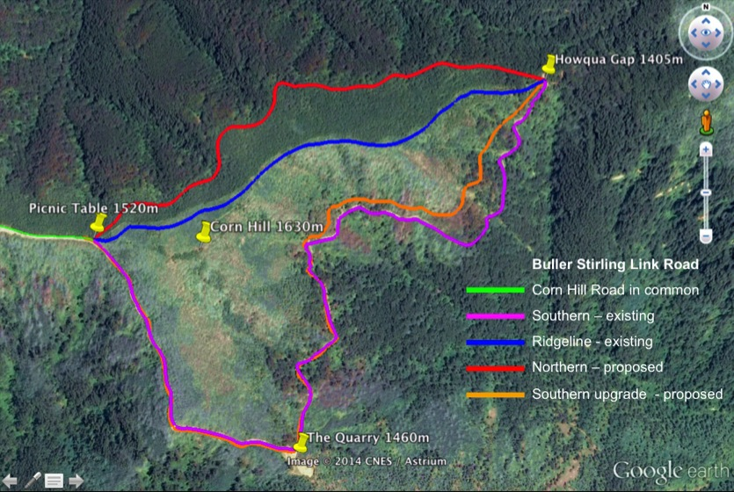

Map derived from Metropol (2013:7) and Google Earth. Prepared by Charles Street

As the Buller Stirling Link Road planning application has been in the approval “pipeline” since 2008, it has fallen under three administrations;

* Bracks/Brumby Labor government
* Baillieu/Naphthine Liberal/LNP government
* Andrews Labor government

The Alpine Resorts (Management) Act 1997 has applied throughout, with some amendments. However, there was a significant shift in government policy regarding the detailed strategies for the Alpine Resorts.

When the first permit application for the Buller Stirling (Touring) Link Road was submitted, the *Alpine Resorts 2020 Strategy (2004)* applied. There is mention of the Link Road in that document;

“Future opportunities”

* “Pursue the opportunity of providing an easily accessible walking and ski touring trail between Mount Buller and Mount Stirling.
* Upgrade the Mount Buller to Mount Stirling road link via Corn Hill.”

*Alpine Resorts 2020 Strategy (2004:39)*

One could be forgiven for assuming that the term “upgrade” referred to the existing Corn Hill Road, to the south of Corn Hill.

After the election of the Baillieu/Naphthine government, the strategy was changed;

“The plan identifies several key infrastructure investment projects, including:

* constructing the Buller-Stirling Touring Link Road to improve access between the mountains and provide an alternative route to Mount Buller in the event of land slip, fire or similar issues”

*Alpine Resorts Strategic Plan 2012 (2012:47)*

Notice that a walking/ski touring trail is not mentioned.

The *Alpine Resorts Strategic Plan 2012* is still current under the Andrews Labor government.

After objections from the Victorian National Parks Association (VNPA), the Mount Stirling Development Taskforce (MSDTF), and others, planning application 2008/0980 was granted a permit by the then Planning Minister, Mr Matthew Guy, 24 March 2014. However, the Minister declined to *issue* that permit, as the permit had sixteen conditions attached. In my opinion, some of those conditions were onerous, arguably insuperable.

After a complex appeal process, and hearings by an Advisory Committee appointed by the new Minister for Planning, Mr Richard Wynne, the matter new resides with Mr Wynne.

Along the way, I have been struck by the fact that none of the authorities involved the approval process have said “No”. In my opinion, this fact merits a robust investigation.

**Evidence of "less than rigorous", or "applying standards less strict than usual", or showing "insufficient diligence”.**

Generally, in this section of my letter, I will follow the process outlined in the 2008/0980 Delegates’ Report of 4 February 2014. The Delegates’ Report is a Departmental summary of all the reviews and responses by government authorities regarding a planning application. It is a summary prepared for the Minister, which the Minister then relies upon when making the final decision.

However, I will first consider what is missing from the Delegates’ Report. That is, a review of the proposal by the Alpine Resorts Management Board (ARMB) itself.

**ARMB**

The ARMB should have been the first of the government authorities to say review the proposal and say “No”. Cogent arguments can be made that a road through the intact high conservation significance subalpine forests of Corn Hill is *delinquent* with respect to all of the following;

***Alpine Resorts 2020 Strategy*** (2004)

4.1 Biological diversity

4.2 The precautionary principle

5.5 Environmental management

5.6 Stewardship of public land

6.3.9 Alpine Resorts Planning Scheme

6.6.1 Public land

7.3 Mount Buller (an upgrade is required, not a new road)

***Alpine Resorts Strategic Plan 2012***

2.4 Environmental outcomes

2.6 Economic/financial viability (we have now been officially refused access to the Link Road Business Case a total of 8 times.)

3.5 Strategic Objective 4: Respecting the alpine environment

3.7.1 Enhancing resort strategic planning (Mount Stirling does not yet have a Resort Master Plan, and the latest Strategic Plan is incomplete with respect to Mount Stirling.)

3.7.4 Fire management (the proposed road is intended to improve fire and emergency access, but is not mentioned or demanded in any fire management plan that we can find. The CFA has not requested a new fire access road across Corn Hill.)

***Native vegetation clearing rules***

The native vegetation clearing rules have been in a state of flux for several years.

It is indisputable, however, that the land upon which the proposed road would be built is covered with intact sub-alpine vegetation of high and very high conservation significance, also referred to as “high risk” from a biodiversity perspective. These forests are habitat to several threatened species. As there are no residences or structures in the vicinity of the proposed road, the vegetation should not be cleared. The ARMB should never allow this.

See also Planning Scheme clause 52.17

***Planning Scheme***

12.03-2 Sustainable development in alpine areas (proposed road bisects a fragile alpine ecosystem)

14.02 Water (proposed road is at “high risk” of land slippage and contamination of the headwaters of the Delatite River)

21.07-3 Settlement (no accommodation is allowed to be constructed on Mount Stirling)

44.01 Erosion management overlay (road area is prone to soil creep, erosion and landslip. Vegetation should not be cleared.)

44.06 Bushfire management overlay (the proposed road is approved by the CFA only for “leisure and recreational purposes” i.e. nordic skiing. The CFA has not approved the road for any other purpose including fire access. Still, it looks good to have a CFA stamp of approval, no matter how irrelevant to “protecting lives and property”.)

52.17 Native vegetation (clearing can be avoided by not building the road.)

***Alpine Resorts (Management) Act 1997***

Clause 56A requires

“As soon as practicable after the commencement of this section, the Board of an alpine resort must commence to prepare a Strategic Management Plan for the resort.”

There is a current Resort Master Plan for Mount Buller, but not for Mount Stirling.

Whilst a Strategic Plan has been prepared for the combined resorts, it is not complete with respect to Mount Stirling. Why is this ?

It would appear that this lack of formal planning for Mount Stirling is a breach of the Alpine Resorts (Management) Act.

***Alpine Resorts Co-ordinating Council (ARCC)***

The proposed road is the subject of a grant application under the Victorian Alpine Resorts Development Program (VARDP). It is claimed by the ARMB that the proposal does not have anything more that a “draft” Business Case. There is no current Mount Stirling Alpine Resort Master Plan, and the current Strategic Plan is not complete with respect to Mount Stirling. Therefore the grant application cannot conform to the rules of the VARDP. Any decision by VARDP based on the submitted documents would therefore be unsafe and extraordinarily vulnerable to legal action.

***Business Case***

The planning application rules do not require a Business Case to be produced for 2008/0980. However, the ARCC does require a “robust business case” for grant applications under VARDP. We know that the latest version of the Business Case is dated May 2011. However, the ARMB still describes that version as a “draft”.

We have now been formally refused access to the Business Case a total of eight times.

“Draft” or “robust”, the public is entitled to know how much public money is being spent on a public road, on public land, under the administration of a public authority, for use by the public.

**Delegates’ Report**

“10 The northern alignment was considered the preferred alignment for the following reasons:

* “It has reduced length”  
  Comment: True. Northern = 2.42 km. Southern upgrade = 4.1 km
* “Less native vegetation removal is required.”  
  Comment: The quantum of native vegetation removal is equivalent for the proposed northern and contemplated southern upgrade, however the conservation value of the vegetation on the northern route is much higher.
* “Reduced gradient, which results in safer construction conditions and use and reduced extent of cut and fill.”  
  Comments: The claim of reduced gradient along the northern route is mathematically wrong. No claims can be made regarding “reduced extent of cut and fill” because no detailed geotechnical studies have been completed. The extent of cut and fill is not determined.
* “Better geotechnical conditions resulting in reduced recurrent costs and reduced geotechnical risks.”  
  Comments: No claims can be made regarding geotechnical conditions and risks because the necessary detailed geotechnical studies have not been done. No claims, other than guesstimates can be made regarding construction and recurrent costs until the geotechnical studies have been completed. The planning application document (Metropol 2013) does not include any data relating to costs, so no claims can be made regarding costs. The Business Case is a secret and we are not permitted to know what the costs and benefits might be. Claims regarding costs are not supported by evidence.
* “Reduced visual impact as the alignment extends through Alpine Ash.”  
  Comments: Visual impacts depend on who is looking from where. No visual impact study is available other that the one I did myself.

**Figure 2 – Visual impacts study**

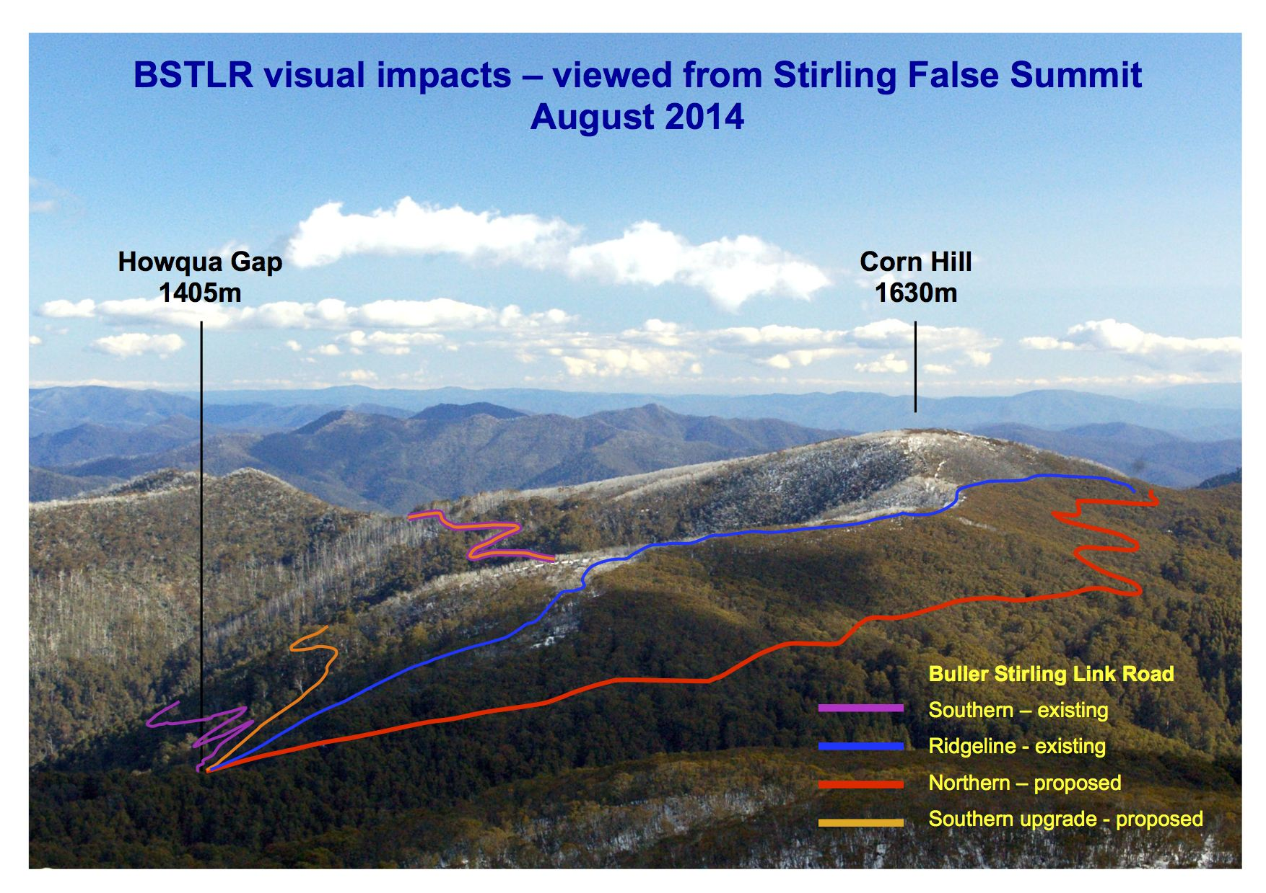

Diagram is a composite of maps by Metropol (2013:7) and Google Earth. and a photograph of Corn Hill taken from the False Summit of Mount Stirling. Diagram prepared by Charles Street.

Comment: A glaring omission from this section of the Delegates’ Report is an evaluation of the following claim by Metropol;

“A comprehensive comparison of the northern and southern alignments has been undertaken over the last two years against the project objectives, with a particular focus on environmental and geotechnical considerations.”

Metropol (2013:7)

As no detailed geotechnical studies have been completed, the statement above cannot be true. Yet the Delegates, and those who assisted them, did not say anything about this stark anomaly in their report. Why not ?

“19 The subject site is affected by EMO1 under Clause 44.01 of the Scheme, with the respective objectives:

* To ensure that applications for development are supported by adequate investigation and documentation of geotechnical and related structural matters.”

Comment: The necessary detailed geotechnical studies have not been done.

Nobody noticed ?

“24 The purpose of Clause 52.17 is:

* To ensure permitted clearing of clearing of native vegetation results in no net loss in the contribution made by native vegetation in Victoria’s biodiversity. This is achieved through the following approach;
* Avoid the removal of native vegetation that makes a significant contribution to Victoria’s biodiversity.”  
  etc.

Comment: This is another point at which public officials should have just said “No”. Why didn’t they ?

“28 The Alpine Resorts 2020 Strategy, now replaced by the Alpine Resorts Strategic Plan 2012 (the Plan) must be considered under Clause 12.03. The Plan provides strong policy support the Link Road and identifies it as a key infrastructure project that would greatly improve access between the mountains for tourism and emergency access.”

Comments: The merits of the proposed road for emergency access are dubious to say the least. If there is an alpine bushfire, the proposed road would take people from Mount Buller deeper into forested areas, contrary to the ARMB’s own advice. As far as tourism is concerned, I have yet to see a single proposal regarding the claimed tourism benefits. Why did our public officers not question these claims ?

“29 The Link Road is also identified in the 2007 Report from the Ministerial Taskforce on Bushfire Recovery. The State government has provided $1.55 million towards the construction of a high-level link road between Howqua Gap and the existing Corn Hill Road to provide all-year access for enhanced emergency response capabilities and tourism opportunities.”

Comments: As mentioned earlier, there are no available details regarding how the proposed road would be used for “enhanced emergency response capabilities and tourism opportunities”. Under FOI, I have now been twice denied access to the application and approval documents relating to this strange grant of $1.55 million. Why is it that our public servants seem not to have asked any questions about these matters ?

“38 Pursuant to Section 57B of the Act, notification of the application was sent to:

* DEPI
* Goulburn Broken Catchment Management Authority
* Victorian National Parks Association

Comments: To their credit, DEPI raised many serious concerns regarding the proposed road. That said, the DEPI submission still concluded with the words “DEPI does not object to a permit being granted, subject to the following conditions being included within the permit:…” (there is a page of conditions).

If the proposal was so problematic, why didn’t they just say “No” ?

“49 Under Section 57C of the Act the application was referred to:

* Country Fire Authority (CFA)
* DEPI
* Goulburn-Murray Water
* Goulburn Valley Water

Comments: The inputs from the water authorities were interesting.

GMW responded with “GMW has no objection to this planning permit being granted subject to the following conditions;

…sediment controls…

…compliance with the Environmental Management Plan 2013…

…may need a licence from GBCMA to undertake works…

…native vegetation within 30 metres of a waterway should be maintained…

GVW responded with a similar degree of repose: “The Corporation…does not object to…granting the permit.” But GVW did insist on stringent sediment controls and notice of any release of sediment loads into the Delatite River, so that they could issue “Boil Water Notices” to downstream townships.

Now let us take a look at the landslide risk perched directly above the Delatite headwaters.

Figure 3 – Landslide risk along the proposed road alignment.

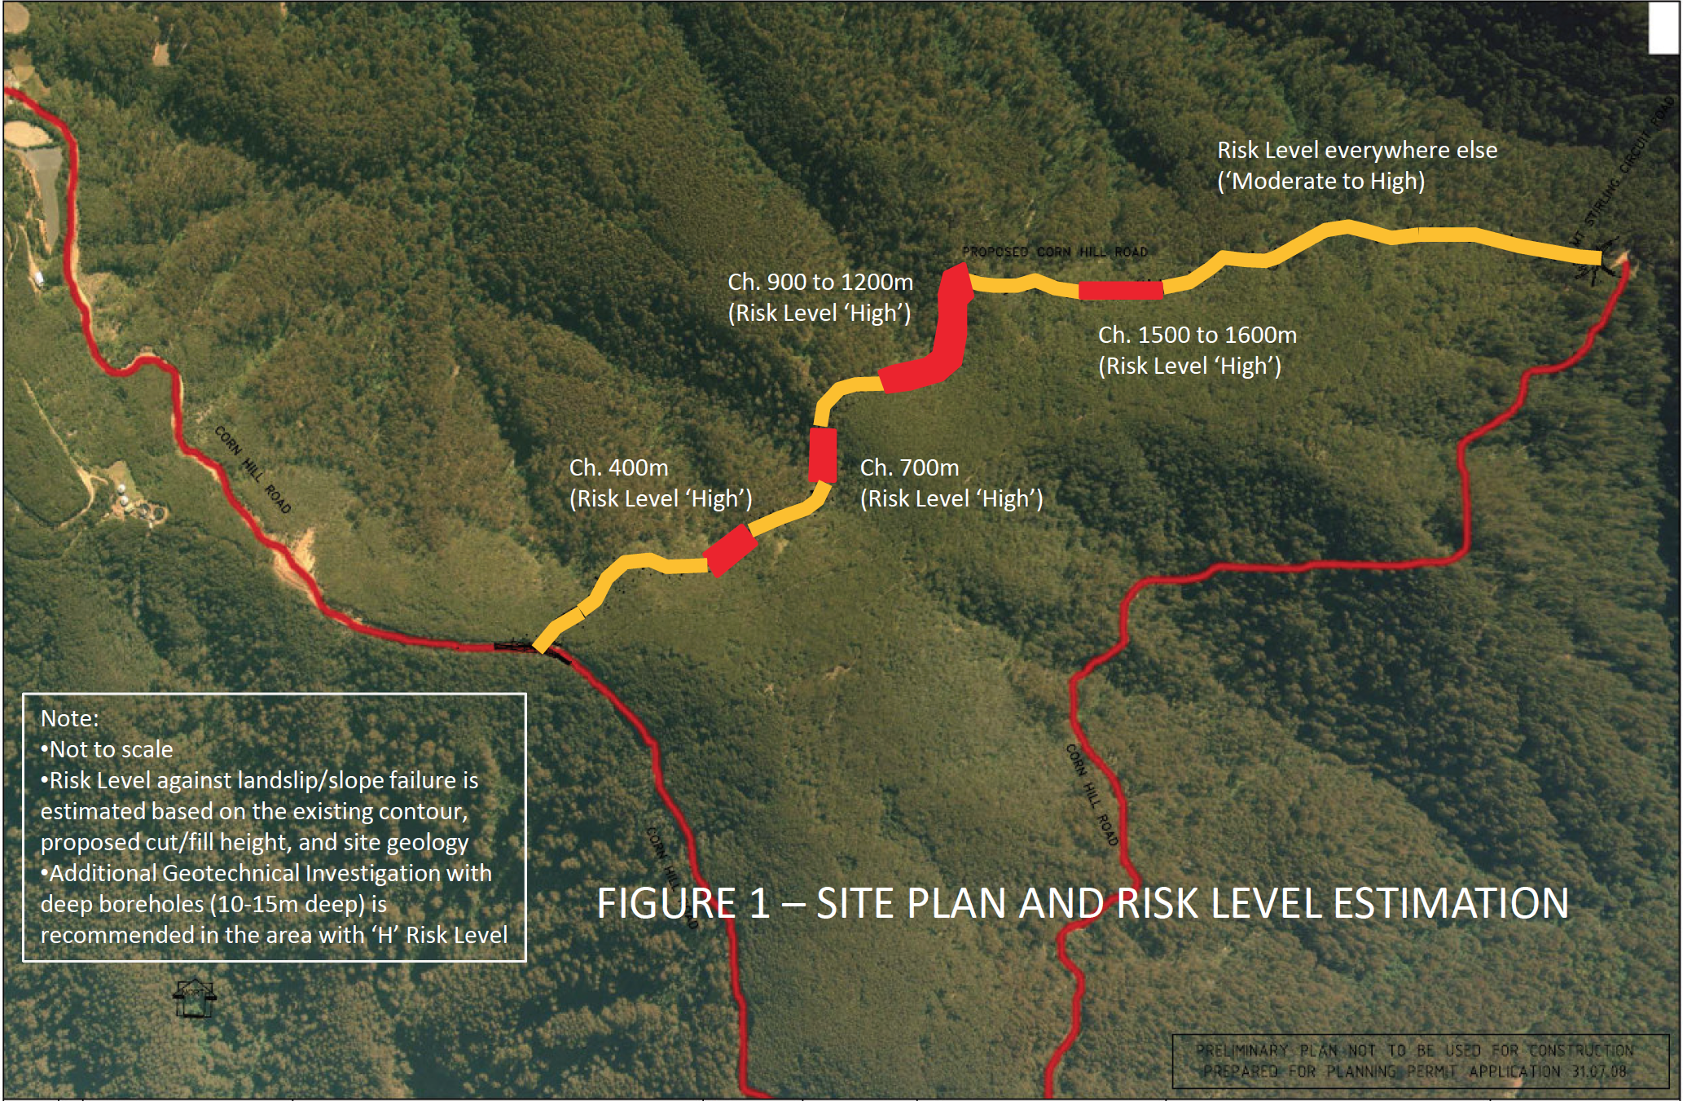

Risk of land slippage along northern road alignment, as estimated by Jamison & Craig (2009).

Figure 4 – Location of the proposed road directly above the Delatite headwaters.

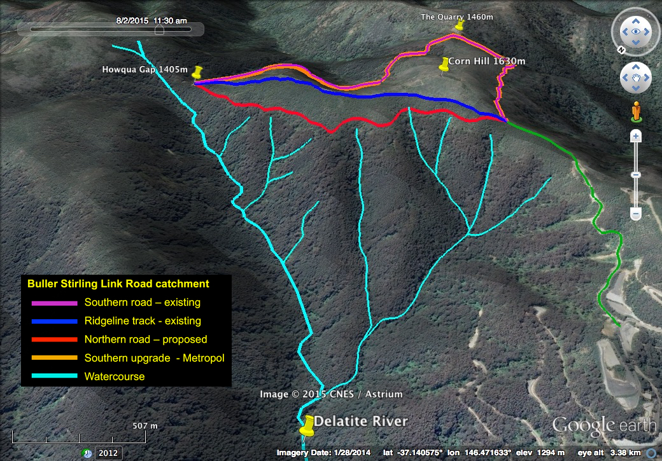

Map derived from Metropol (2013), Google Earth and The Land Channel. Prepared by Charles Street

The upper tributaries of the Delatite have certainly been habitat for the critically endangered native fish *Galaxias fuscus*. Some *Galaxias* may still live in these waters, but we do not know.

Why did the water authorities not respond with *alarm* ?

Why didn’t they just say “No” ?

“55 The applicant submitted a Bushfire Management Statement in accordance with the requirements of the BMO.” (Bushfire Management Overlay)

Comments: Again, our public officials did not seem to take a close look at the Bushfire Management Statement from Terramatrix, other than the magic words at the end, “the proposed development successfully complies with all of the relevant bushfire safety objectives and standards.”

Some the words before this are not so reassuring.

“**Bushfire risk assessment**

The development could be exposed to a large, severe bushfire of the scale and intensity presumed in the BMO model, which would most likely approach from the northwest, or from the southwest under a southwesterly wind change typically associated with severe fire weather.”

*Terramatrix (2013:3)*

Indeed, the entire south face of Corn Hill was consumed by fire in the summer of 2006/7.

“**Justification**

The link road will not increase the risk to life, property or community infrastructure.”

*Terramatrix (2013:5)*

This statement is true, provided nobody builds anything on Corn Hill, nobody tries to escape Mount Buller along the proposed road during an alpine bushfire, and the CFA does not use the proposed road for any purpose, under bushfire conditions.

“A static water supply is also not proposed for the link road because Mt Buller is approximately 1.2 kilometres to the west, which contains a number of hydrants. Large dams and water storage areas are found in the area that can be used by aerial appliances to collect water in times of emergency.”

*Terramatrix (2013:8)*

The implication of these remarks is that the Mount Buller Village is the safest place to be in the event of a bushfire in these mountains. I agree with that. Indeed the Village has its own fire brigade and at least one Neighbourhood Safer Place. In theory, people can be rescued by helicopter, if necessary.

We can deduce from the Terramatrix remarks that the last thing anyone would want to do in an alpine bushfire is to try to escape the Mount Buller Village by travelling along any road through the forests of Corn Hill, to the forests of Mount Stirling, where there are no fire fighting facilities, no Neighbourhood Safer Places, and no water supplies.

Again, our public servants seemed to have missed these details and continued to support the view that the proposed road would perform a useful role in fire and other emergency situations. Why ?

**“Discussion**

62 …”The relevant authorities had no objection to the proposal subject to conditions. Therefore, it is recommended that the proposal be supported subject to conditions.”

Comment: Unbelievable.

Yours faithfully

Charles Street B. Sc. Agr., MRACI, Grad. Dip. Quality Technology, Grad. Dip. Education.

36 Sutherland Street, Euroa, Victoria, 3666

Mob: 0427 147 007

Email: [cjstreet@bigpond.net.au](mailto:cjstreet@bigpond.net.au)

**References**