To

Freedom of Information Commissioner

PO Box 24274, Melbourne, Victoria, 3000

# About this form

Use this form to request the Freedom of Information (FOI) Commissioner to review a decision of a Victorian agency about a freedom of information application you made to the agency[1] under the *Freedom of Information Act 1982* (the Act).

# What to read before you start

Before completing this form, read the section below ‘Decisions the FOI Commissioner cannot review’.

# Decisions the FOI Commissioner cannot review

1. The FOI Commissioner cannot review decisions made by government departments, councils and other agencies that:

* involve Cabinet documents
* concern documents affecting national security, defence or international relations, or
* are made by the Secretary of a government department, the chief administrative officer of a council or the principal officer of all other agencies.

1. The FOI Commissioner cannot review a decision made by a Minister at any time.

*If you are unsure as to whether the decision was made by the principal officer of an agency, please contact the Office of the FOI Commissioner on 1300 VIC FOI (1300 842 364) or by email to enquiries@foicommissioner.vic.gov.au.*

*If the decision you wish to have reviewed falls into one of the categories above, you may seek a review of the decision by the Victorian Civil and Administrative Tribunal (VCAT). More information about this option is provided below.*

# Decisions the VCAT can review

VCAT can review decisions made by Ministers and decisions of a government department, council or other agency:

* involving Cabinet documents
* concerning documents affecting national security, defence or international relations, or
* made by the Secretary of a government department, the chief administrative officer of a local council or the principal officer of all other agencies.

More information about VCAT is available at [*http://www.vcat.vic.gov.au/*](http://www.vcat.vic.gov.au/), by email [*vcat-admin@justice.vic.gov.au*](mailto:vcat-admin@justice.vic.gov.au)or by phone (03) 9628 9755.

# How long do I have to apply for a review?

Your application for review must be made to the FOI Commissioner within 28 days after the day you are given a notice in writing of the agency’s decision.

If the decision was to refuse to grant access to a document containing health information on the ground in section 36 of the *Health Records Act 2001*, you have 70 days after the day you are given a notice to apply for review.

# More information

# **If you have any questions about this form or the application process, please phone us on 1300 842 364, email us at** [***enquiries@foicommissioner.vic.gov.au***](mailto:enquiries@foicommissioner.vic.gov.au)**, or visit our website *www.foicommissioner.vic.gov.au*.**

# 1) Your details **– You must complete this section**

|  |  |  |  |  |  |  |  |  |  |  |  |  |  |  |  |  |  |  |  |  |
| --- | --- | --- | --- | --- | --- | --- | --- | --- | --- | --- | --- | --- | --- | --- | --- | --- | --- | --- | --- | --- |
| Title: | Mr | | Given Name(s): | | GERARD | | | | | | | Surname: | | | | MCPHEE | | | | |
| Your organisation (*if applicable*): | | | | |  | | | | | | | | | | | | | | | |
| Email address: GERARD@FASTMAIL.COM.AU | | | | |  | | | | | | | | | | | | | | | |
| Street or postal address:  10 CCUBBIN STREET | | | | |  | | | | | | | | | | | | | | | |
| Suburb/Town: | | KEW EAST | | | | | State/Territory: | | | | VIC | | | | | | Postcode: | | | 3102 |
| Phone (daytime): | | | | ( ) | | | | | Mobile: | | | | 0467013966 | | | | | | | |
| Preferred method of contact? | | | | | NO | ~~Phone~~ | | YES | | Email | | | | NO | ~~Mobile~~ | | | NO | ~~Post~~ | |

# 2) Other requirements when contacting you

Is there anything else we should know when contacting you?  Yes  No

If yes, please provide details:

|  |
| --- |
| In the event that I am difficult to find, please contact Mr Charles Street as follows.  Charles Street,  36 Sutherland Street, Euroa, 3666. Mob: 0427 147 007  Charles Home Street <cjstreet@bigpond.net.au  **He is authorized to receive mail and make decisions on this matter if I am not available or hard to contact. I am not making this enquiry “on his behalf” He is a co-applicant.** |

Do you need an interpreter?   No NO

# 3) If you apply on behalf of another person

Please complete the section below if you are requesting a review of an application on behalf of another person.

You will need the written authorisation of this person for you to apply on their behalf.

|  |  |  |  |  |  |  |  |  |  |  |  |  |  |  |  |  |  |  |  |
| --- | --- | --- | --- | --- | --- | --- | --- | --- | --- | --- | --- | --- | --- | --- | --- | --- | --- | --- | --- |
| Are you making this application on behalf of someone else? | | | | | | | | | | | |  | |  | |  | | No | |
| If yes, please fill in the details of this person: | | | | | | | | | | | | | | | | | | | |
| Title: |  | | Given Name (s): | |  | | | Surname: | |  | | | | | | | | | |
| Email address: | | | | |  | | | | | | | | | | | | | | |
| Street or postal address: | | | | |  | | | | | | | | | | | | | | |
| Suburb/Town: | |  | | | | State/Territory: | |  | | | Postcode: | | | | |  | | | |
| Their phone (daytime) | | | | (  ) | | | Mobile: | |  | | | | | | | | | | |
| Your relationship to this person: | | | | |  | | | | | | | | | | | | | | |
| Why are you applying on this person’s behalf? | | | | | | | | | | | | |  | |  | |  | |  |

# 4) Your original request

|  |  |  |  |  |
| --- | --- | --- | --- | --- |
| Please attach a copy of your original request to the agency (if available)**.ATTACHED** | | | | |
| Have you attached a copy of your original request to this application? |  | Yes –see below |  |  |
| If not, please provide details below of the documents you requested from the agency. | | | | |
| All docs are attached. | | | | |

# 5) Which decision do you want reviewed? **­– You must complete this section**

|  |  |  |  |  |  |  |  |
| --- | --- | --- | --- | --- | --- | --- | --- |
| An application for review must identify the agency concerned. This is the organisation that made the decision you want reviewed. Please attach a copy of the agency’s decision notice (if available). | | | | | | | |
| Date you received the agency’s decision on your request | | | 10 August 2015 | | | | |
| Have you attached a copy of the agency’s decision notice to this application?  **.ATTACHED** | | | |  | Yes see below |  |  |
| If you have not attached a copy of the agency’s decision, please provide the following details: | | | | | | | |
| Agency Name | |  | | | | | |
| Date of the decision (this is the date of the agency’s decision notice) | | |  | | | | |
| Agency reference number (if contained in the notice) | | | | | | | |
| Name of agency decision maker | | | | | | | |
| Please tick one or more of the boxes below to indicate what the agency decided: | | | | | | | |
|  | to refuse access to a document (or parts of a document) you requested | | | | | | |
|  | to defer access to a document you requested | | | | | | |
|  | not to waive or reduce an application fee | | | | | | |
|  | not to amend a document with personal information | | | | | | |

# 6) How to submit this application

Please submit your completed application to the FOI Commissioner by:

|  |  |
| --- | --- |
| Email | [*enquiries@foicommissioner.vic.gov.au*](mailto:enquiries@foicommissioner.vic.gov.au) |
| Post | PO Box 24274, Melbourne, Vic 3000 |

# 7) What happens next?

An initial assessment of your application for review will be conducted. We will contact you to acknowledge receipt of your application and for any further information. The FOI Commissioner has 30 days after we receive your application to complete a review, unless you agree to a longer period in writing.

# 8) Privacy information

We will handle your personal information in accordance with the *Information Privacy Act 2000* (Vic), the *Health Records Act 2001* (Vic) and the *Charter of Human Rights and Responsibilities Act 2006* (Vic).

# 9) Consent **– You must complete this section**

I consent to the FOI Commissioner making enquiries of the agency, persons I have named and any other appropriate person or body regarding my application for review and for the agency to provide any necessary documentation to the FOI Commissioner.

|  |  |  |  |
| --- | --- | --- | --- |
| ***Gerard McPhee by email*** | Date: | |  |
| Your signature |  | | |
| If submitting this form electronically, please give consent by ticking this box - | X tick | Date: | 28 August 2015 |

# 10) Consent of other person (where applicable)

I consent to the FOI Commissioner making enquiries of the agency, persons named in this form and any other appropriate person or body regarding this application for review and for the agency to provide any necessary documentation to the FOI Commissioner.

|  |  |  |  |
| --- | --- | --- | --- |
|  | Date: | |  |
| Your signature |  | | |
| If submitting this form electronically, please give consent by ticking this box - |  | Date: |  |

# 11) Checklist

X All relevant parts of the form have been completed.

X The consent parts of the form have been signed. **By email**

X A copy of the original FOI request has been attached (if available).

X A copy of the agency’s decision notice has been attached (if available).

X The following supporting documents/further information has been attached to this application:

Dear Freedom of Information Commissioner,

I am seeking a review of a refusal by a statutory authority to release information. The request document and the refusal are included in this request for review. See below.

The refusal included a few documents on different grounds.

One such document is the subject of a separate application for review. (FOI Review Matter - C-16-00137) I am happy for the matters to be dealt with separately.

The request was as follows. (This is an extract from the full documentation which is at the end of this document.

**Business Case**

*I am seeking the May 2011 updated business case for the Corn Hill link road. I am not seeking earlier documents in this FOI request…..*

The refusal was as follows.

*May 2011 Business Case Update*

1. *“In relation to the May 2011 Business Case Update, the document is exempt from release pursuant to section 30 of the Act, namely that it is an internal working document the release of which would be contrary to the public interest. The basis for this decision is that the document would disclose matter in the nature of opinion, advice and recommendations of the Board in the course of its deliberative processes, and would be contrary to public interest in that it relates to an ongoing project that has not yet been finalised or put out to public tender, that by its release it could disadvantage the Board in any future commercial negotiations, and could engender uninformed and unnecessary public debate in circumstances where the project is not yet finalised and its commercial and other objectives are still under review.”*

My appeal is based on the understanding that the Buller/Stirling Alpine Resort Management Board (Hereafter BSARMB) has used the business case as a final and formal document and therefore it is not a draft or internal working document.

I suggest that, once a Business Case has been submitted to another entity, e.g. the Alpine Resorts Co-ordinating Council, in support of a grant of public monies, that Business Case received can no longer be considered “an internal working document”.

The ARCC adjudicates the granting of public monies for alpine development projects. The ARCC actively uses the documents called “business case” and “strategic plans” to deliver its key deliverables. This is set out in the policies of the Victorian Alpine Resorts Development Project (VARDP) grants.

“**Victorian Alpine Resorts Infrastructure Project List**

The purpose of this list is to informal government and other potential funding partners of the infrastructure investment priorities across the Victorian alpine resorts. The list and associated information will be used to progress the projects, including applications for funding.

Projects on the list have undergone a comprehensive review process based on the Department of Treasury and Finance’s Investment Management Standard. They are supported by **robust business cases** and are aligned with resort, regional and state-wide strategic plans. **They have been considered and endorsed by the Alpine resorts Co-ordinating Council (ARCC) in conjunction with representatives of the Alpine Resort Management Boards (ARMBs).**

**(My emphasis)**

The list is a key output of the Victorian Alpine Resorts Development Program (VARDP), managed by the ARCC.”

See <http://arcc.vic.gov.au/vardp> and the links therein.

For example the business case referred to in this application for review has been deemed to be sufficient to allow the subject of the business case to proceed. It is now **a tier one project** and thus the document cannot be a “draft” or working document. The formal status of the project and therefore the business case is illustrated thus.

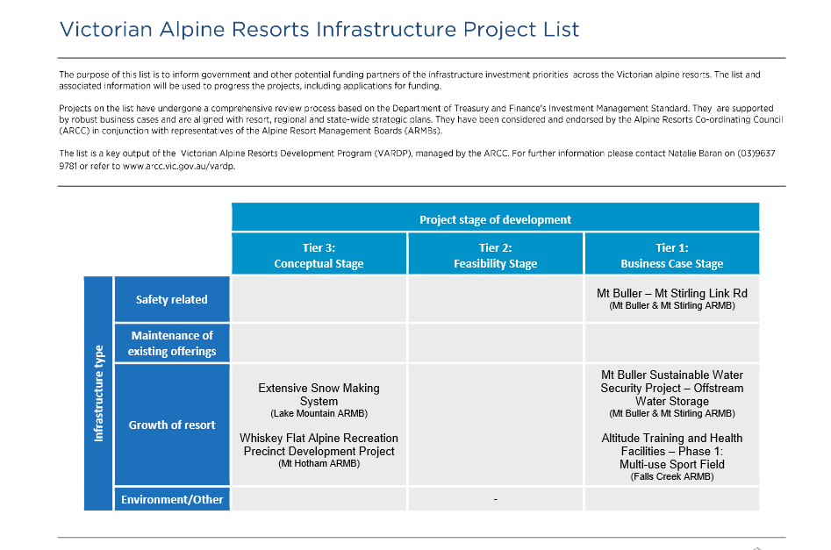

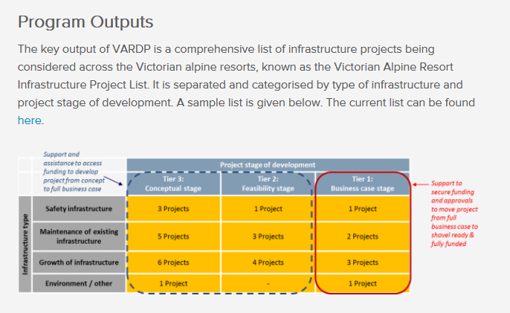

The Business Case and strategic plans are part of the core process of the ARCC and VARDP. The Business Case is part of an application by one public authority to another public authority, for public funds, for a road on public land, under the administration of a public authority, for use by the public. This is about the expenditure of public money, and therefore the requirements of probity are such that the Business Case cannot be a “draft”, or lack finality. The ARCC requires a “robust business case” in conformance with the guidelines of the Department of Treasury and Finance. It cannot be a “draft”. The ARCC would be bound by its own requirements to reject an incomplete or “draft” business case.

The Business Case is part of an application by one public authority to another public authority, for public funds, for a road on public land, under the administration of a public authority, for use by the public. This is about the expenditure of public money, and therefore the requirements of probity are such that the Business Case cannot be “draft” or lack finality. The ARCC requires a “robust business case” in conformance with the Department of Treasury and Finance’s Investment Management Standard, thus it cannot be a “draft”. The ARCC would be bound by its own requirements to reject an incomplete or “draft” business case.

**THE REQUEST FOR INFORMATION THAT WAS SUBMITTED TO THE BULLER/STIRLING BOARD OF MANAGEMENT.**

# **From:** Gerard [<mailto:gerard@gerard.com.au>] **Sent:** Wednesday, 24 June 2015 12:17 PM **To:** Glenn Thornton **Subject:** BSTLR FOI 20150624 Gerard McPhee Replacement FOI request.

**TO THE FOI OFFICER MT BULLER/STIRLING ALPINE RESORT MANAGEMENT BOARD.**

REPLACEMENT FOI REQUEST

Dear Glenn,

Thank you for your help over the phone this morning.

What follows is my **REPLACEMENT FOI** request.

I am happy to refine it further after discussion to make it easier for you to accept.

**Black Forest Lodge**

I  require the visitor days/occupancy nights of each "official visitor" to Black Forest Lodge, and  to the extent known, the organizations they represent and the purpose of the visit. I only require this for the past the five years.

By "Official Visitor" I mean anyone employed or representing any state government department or statutory authority. This would include the following statutory authorities such as the CFA, VicRoads, EPA, DEPI,  Victoria Police, State Emergency Service (SES), Department of Human Services (DHS), DELWP. This is not exhaustive as there may be other state instrumentalities concerned with water,soil fauna, flora or planning that I have not included.

The information can be provided from the databases or records which is used in managing the bookings. A simple data extract would be sufficient in XLS or other commonly used file structure. All databases have an extract feature and such a report should generally be able to be  provided in an hour or so.

**Business Case**

I am seeking the May 2011 updated business case for the Corn Hill link road. I am not seeking earlier documents in this FOI request.

**Master Plan V2**

Please supply the October 2010 Part 2 of the Master Plan. As this runs to 220 pages, I am happy for you to send it by CD or memory stick or for you to post it on the MBSARMB website.

Do not hesitate to call me if I can further clarify my replacement FOI request.

Gerard McPhee

10 McCubbin Street

East Kew 3102

Australia

0467013966

# **COPY OF REFUSAL TO RELEASE NOTICE FROM THE MT BULLER BOARD.**

# 10 August 2015

By Email: gerard@fastmail .com.au

Mr Gerard McPhee 10 Mccubbin Street

EAST KEW VIC 3102

Dear Mr McPhee,

# FOi Request to Mt Buller & Mt Stirling Alpine Resort Management Board ("Board") Corn Hill Link Road Project

I refer to your reformulated FOi request dated 24 June 2015 .

Thank you for your payment of $25 on account of the deposit, received on 25 June 2015.



A. Partial Release

*Black Forest Lodge Accommodation Records*

1. In relation to the Black Forest Lodge Accommodation Records - Chart of Accommodation Records from 2010 to 2015, to partially release the information, but with personally identifying information redacted, pursuant to section 33 of the Act. The basis for this decision is that the accommodation of persons at the Lodge is a personal matter to those individuals, in that persons accommodated were not performing in their official capacities whilst in their accommodation.

*Mt Buller Master Plan Report Volume 2*

1. In relation to Mt Buller Master Plan Report Volume 2 October 2010, to partially release the document but with the following information redacted:
   1. Appendix A2: Numeric targets in the "design" column. This is because the information is an internal working document, is speculative in nature and in draft form, and consequently could engender uninformed and unnecessary public debate. This is a section 30 exemption .
   2. Appendix 7: Preliminary Economic Assessment, Page 8 of the SGS Report, Table 1, breakdown of financial totals. Indicative costs information would be likely to disadvantage the Board in negotiating and/or tendering for some of the listed projects. This is a section 34(4)(a) exemption.
   3. Appendix 7: Preliminary Economic Assessment, Page 9 of the SGS Report, the individual totals listed per site which show the private investment potential expected to be leveraged per site. These projects are yet to be released publically or go to tender, and would be likely to disadvantage the Board if the amounts were released publicly. This is a section 34(4)(a) exemption.

8. No Release

*May 2011 Business Case Update*

1. In relation to the May 2011 Business Case Update, the document is exempt from release pursuant to section 30 of the Act, namely that it is an internal working document the release of which would be contrary to the public interest. The basis for this decision is that the document would disclose matter in the nature of opinion, advice and recommendations of the Board in the course of its deliberative processes, and would be contrary to public interest in that it relates to an ongoing project that has not yet been finalised or put out to public tender, that by its release it could disadvantage the Board in any future commercial negotiations, and could engender uninformed and unnecessary public debate in circumstances where the project is not yet finalised and its commercial and other objectives are still under review.

Fees

I advise that the Board has incurred a total cost of $69.20 in processing your request, searching for and collating the information, and acquiring a USB memory stick for the documents. Taking into account the $25 deposit already paid, please make payment of $44.20 by way of EFT to:

Account Name: BSB:

Mt Buller Mt Stirling Alpine Resort Management Board 083-755

Account number: 485234410 Reference: McPhee-FOI

Upon receipt of your payment, I will be pleased to immediately release the indicated documents. Review of decision

You have the right to request a review of the decision in this matter.

Should you wish to have the decision reviewed by the Freedom of Information Commissioner, the request for a review must be received within 28 days from receipt of this letter. An Application for a review must be made in writing and addressed to:

Office of the Freedom of Information Commissioner PO Box 24274

MELBOURNE VIC 3001

Should you wish to have the decision reviewed by VCAT, the Application for review must be made within 60 days from receipt of this letter. An Application for a review must be made in writing and addressed to:

Victorian Civil and Administrative Tribunal 55 King Street,

MELBOURNE VIC 3000.

Should you wish to discuss any aspect of this letter with me, please do not hesitate to contact me as required.

Glenn Thornton

Chief Financial Officer & FOi Officer

1. This means a government department, a local council and one of certain other bodies defined in the FOI Act.