About this form
Use this form to request the Freedom of Information (FOI) Commissioner to review a decision of a Victorian agency about a freedom of information application you made to the agency under the Freedom of Information Act 1982 (the Act).

What to read before you start
Before completing this form, read the section below ‘Decisions the FOI Commissioner cannot review’.

Decisions the FOI Commissioner cannot review
- The FOI Commissioner cannot review decisions made by government departments, councils and other agencies that:
- involve Cabinet documents
- concern documents affecting national security, defence or international relations, or
- are made by the Secretary of a government department, the chief administrative officer of a council or the principal officer of all other agencies.

- The FOI Commissioner cannot review a decision made by a Minister at any time.
If you are unsure as to whether the decision was made by the principal officer of an agency, please contact the Office of the FOI Commissioner on 1300 VIC FOI (1300 842 364) or by email to enquiries@foicommissioner.vic.gov.au.
If the decision you wish to have reviewed falls into one of the categories above, you may seek a review of the decision by the Victorian Civil and Administrative Tribunal (VCAT). More information about this option is provided below.

Decisions the VCAT can review
VCAT can review decisions made by Ministers and decisions of a government department, council or other agency:
- involving Cabinet documents
- concerning documents affecting national security, defence or international relations, or
- made by the Secretary of a government department, the chief administrative officer of a local council or the principal officer of all other agencies.
More information about VCAT is available at http://www.vcat.vic.gov.au/, by email vcat-admin@justice.vic.gov.au or by phone (03) 9628 9755.

How long do I have to apply for a review?
Your application for review must be made to the FOI Commissioner within 28 days after the day you are given a notice in writing of the agency’s decision.

If the decision was to refuse to grant access to a document containing health information on the ground in section 36 of the Health Records Act 2001, you have 70 days after the day you are given a notice to apply for review.

More information

If you have any questions about this form or the application process, please phone us on 1300 842 364, email us at enquiries@foicommissioner.vic.gov.au, or visit our website www.foicommissioner.vic.gov.au.

1) Your details – You must complete this section
Title: | Mr |  | Given Name(s): |  | GERARD |  |  |  |  |  |  | Surname: |  |  |  | MCPHEE
Your organisation (if applicable):
Email address: GERARD@FASTMAIL.COM.AU
Street or postal address:
10 CCUBBIN STREET
Suburb/Town: |  | KEW EAST |  |  |  |  | State/Territory: |  |  |  | VIC |  |  |  |  |  | Postcode: |  |  | 3102
Phone (daytime): |  |  |  | ( ) |  |  |  |  | Mobile: |  |  |  | 0467013966
Preferred method of contact? |  |  |  |  | NO | Phone |  | YES |  | Email |  |  |  | NO | Mobile |  |  | NO | Post

2) Other requirements when contacting you
Is there anything else we should know when contacting you? Yes No
If yes, please provide details:
In the event that I am difficult to find, please contact Mr Charles Street as follows.
Charles Street,
36 Sutherland Street, Euroa, 3666.
Mob: 0427 147 007
Charles Home Street <cjstreet@bigpond.net.au
He is authorized to receive mail and make decisions on this matter if I am not available or hard to contact. I am not making this enquiry “on his behalf” He is a co-applicant.
Do you need an interpreter? No NO

3) If you apply on behalf of another person
Please complete the section below if you are requesting a review of an application on behalf of another person.
You will need the written authorisation of this person for you to apply on their behalf.

Are you making this application on behalf of someone else? |  |  |  |  |  |  |  |  |  |  |  |  |  |  |  |  |  | No
If yes, please fill in the details of this person:
Title: |  |  | Given Name (s): |  |  |  |  | Surname:
Email address:
Street or postal address:
Suburb/Town: |  |  |  |  |  | State/Territory: |  |  |  |  | Postcode:
Their phone (daytime) |  |  |  | ( ) |  |  | Mobile:
Your relationship to this person:
Why are you applying on this person’s behalf?

4) Your original request
Please attach a copy of your original request to the agency (if available).ATTACHED
Have you attached a copy of your original request to this application? |  | Yes –see below
If not, please provide details below of the documents you requested from the agency.
All docs are attached.

5) Which decision do you want reviewed? – You must complete this section
An application for review must identify the agency concerned. This is the organisation that made the decision you want reviewed. Please attach a copy of the agency’s decision notice (if available).
Date you received the agency’s decision on your request |  |  | 10 August 2015
Have you attached a copy of the agency’s decision notice to this application?  .ATTACHED |  |  |  |  | Yes see below
If you have not attached a copy of the agency’s decision, please provide the following details:
Agency Name
Date of the decision (this is the date of the agency’s decision notice)
Agency reference number (if contained in the notice)
Name of agency decision maker
Please tick one or more of the boxes below to indicate what the agency decided:
 | to refuse access to a document (or parts of a document) you requested
 | to defer access to a document you requested
 | not to waive or reduce an application fee
 | not to amend a document with personal information

6) How to submit this application
Please submit your completed application to the FOI Commissioner by:
Email | enquiries@foicommissioner.vic.gov.au
Post | PO Box 24274, Melbourne, Vic 3000

7) What happens next?
An initial assessment of your application for review will be conducted. We will contact you to acknowledge receipt of your application and for any further information. The FOI Commissioner has 30 days after we receive your application to complete a review, unless you agree to a longer period in writing.

8) Privacy information
We will handle your personal information in accordance with the Information Privacy Act 2000 (Vic), the Health Records Act 2001 (Vic) and the Charter of Human Rights and Responsibilities Act 2006 (Vic).

9) Consent – You must complete this section
I consent to the FOI Commissioner making enquiries of the agency, persons I have named and any other appropriate person or body regarding my application for review and for the agency to provide any necessary documentation to the FOI Commissioner.
Gerard McPhee by email | Date:
Your signature
If submitting this form electronically, please give consent by ticking this box - | X tick | Date: | 28 August 2015

10) Consent of other person (where applicable)
I consent to the FOI Commissioner making enquiries of the agency, persons named in this form and any other appropriate person or body regarding this application for review and for the agency to provide any necessary documentation to the FOI Commissioner.
 | Date:
Your signature
If submitting this form electronically, please give consent by ticking this box - |  | Date:

11) Checklist
X All relevant parts of the form have been completed.
X The consent parts of the form have been signed. By email
X A copy of the original FOI request has been attached (if available).
X A copy of the agency’s decision notice has been attached (if available).
X The following supporting documents/further information has been attached to this application:
- Grounds for review have been embedded in this document.
- Letter to Ombudsman is attached to the email as context for the argument on “the applicant’s interest”

My reasons for asking for a review of the decision re “Accommodation Records” are as follows.
(Please note that I may submit a subsequent and separate review on the two other matters in the FOI application. However the personal privacy issues can and should be separated out.)

The first decision by the agency was to redact names on the basis of personal privacy under section 33 as follows. The agency advised as follows.
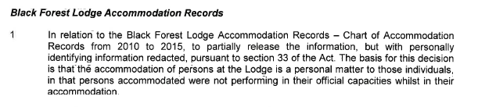

I have attached a copy of the entire agency response at the end of this application for review.
My grounds for asking for a review of the redaction are as follows.

1. The attendance of persons at publically funded accommodation (a benefit available to only a few) is not a personal matter. Guests of this statutory authority concerned receive a significant benefit and thus the matter is one of a query about public expenditure and probity rather than personal affairs. Therefore it is unreasonable to withhold the information on privacy grounds. For example, if a cabinet minister receives a free hotel for week from a corporation, then it is clearly a public matter. Naturally if the guests are fully self-paying and the funds are fully accounted for as revenue by the statutory authority then the matter is indeed “personal” and I have no legitimate interest in the details.

2. A perusal of the redacted records shows that the reasons for the free accommodation are related to highly public events such as “Official opening snow season” or “RAFC meeting” or the “Mt Buller Inter schools” This is not a private event when attendance and accommodation at such a public event is subsidized by a statutory authority. Further I cannot see how it is consistent to claim that persons are not “performing in their official capacities” (as claimed in the reasons for redaction when the released document) when the redacted table shows them as having potentially legitimate reasons to attend in an official capacity. If the guests are genuinely on official business then there is no “personal privacy” issue.

3. One of the issues to be taken into account by a statutory agency before deciding that is it unreasonable to release the information is “The applicant’s interest in the information to be disclosed. I have legitimate reasons for seeking the information and I have set these out in a letter to the Victorian Ombudsman. I am not asking the FOI to repeat any work done by the Ombudsman; I am attaching the correspondence to illustrate the legitimacy of my interest.

4. Even if the matter of visiting Buller in the ski season were to be seen as “private” in a general sense, that information is not automatically exempt. The statutory authority must consider whether disclosure of that personal affairs information is unreasonable.
It is important to begin from a position that the applicant is entitled to access the documents and to only delete information when disclosure would be unreasonable. (Ref http://www.foicommissioner.vic.gov.au/resources/1b0625f1-e960-46bb-9c9f-d68e00d8dbfe/guide-to-section-33.pdf

The main factors to consider when deciding whether disclosure of the personal affairs is
unreasonable include –
The circumstances in which the information was obtained;
***My comment here is that a visitor booking register at a statutory authority is not normally seen as a highly “in confidence” document.
The applicant’s interest in the information to be disclosed;
***See my discussion above re probity and ombudsman issues.
The nature of the information to be disclosed and the information which has
already been disclosed or is on the public record;
***See above discussion point 2. The events are often very public and subject to TV reportage etc.
THE ORIGINAL REQUEST
From: Gerard [mailto:gerard@gerard.com.au]
Sent: Wednesday, 24 June 2015 12:17 PM
To: Glenn Thornton
Subject: BSTLR FOI 20150624 Gerard McPhee Replacement FOI request.

TO THE FOI OFFICER MT BULLER/STIRLING ALPINE RESORT MANAGEMENT BOARD.
REPLACEMENT FOI REQUEST

Dear Glenn,
Thank you for your help over the phone this morning.
What follows is my REPLACEMENT FOI request.
I am happy to refine it further after discussion to make it easier for you to accept.

Black Forest Lodge

I require the visitor days/occupancy nights of each "official visitor" to Black Forest Lodge, and to the extent known, the organizations they represent and the purpose of the visit. I only require this for the past the five years.
By "Official Visitor" I mean anyone employed or representing any state government department or statutory authority. This would include the following statutory authorities such as the CFA, VicRoads, EPA, DEPI, Victoria Police, State Emergency Service (SES), Department of Human Services (DHS), DELWP. This is not exhaustive as there may be other state instrumentalities concerned with water, soil fauna, flora or planning that I have not included.

The information can be provided from the databases or records which is used in managing the bookings. A simple data extract would be sufficient in XLS or other commonly used file structure. All databases have an extract feature and such a report should generally be able to be provided in an hour or so.

Business Case

I am seeking the May 2011 updated business case for the Corn Hill link road. I am not seeking earlier documents in this FOI request.

Master Plan V2

Please supply the October 2010 Part 2 of the Master Plan. As this runs to 220 pages, I am happy for you to send it by CD or memory stick or for you to post it on the MBSARMB website.
Do not hesitate to call me if I can further clarify my replacement FOI request.
Gerard McPhee
10 McCubbin Street
East Kew 3102
Australia
0467013966

THE REPLY FROM THE AGENCY
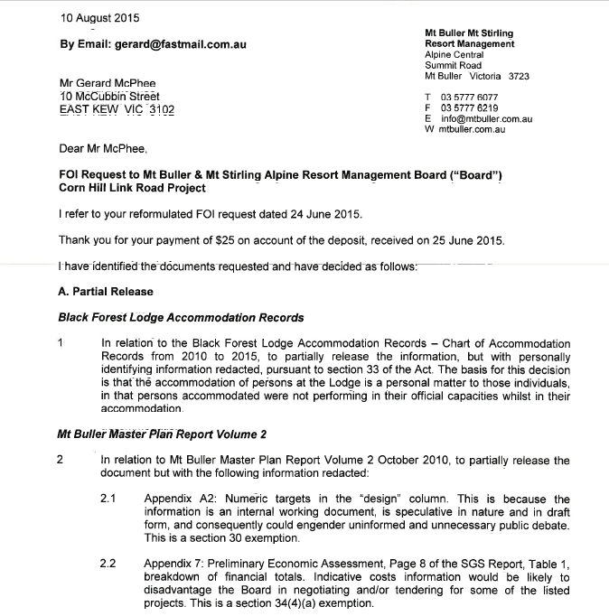

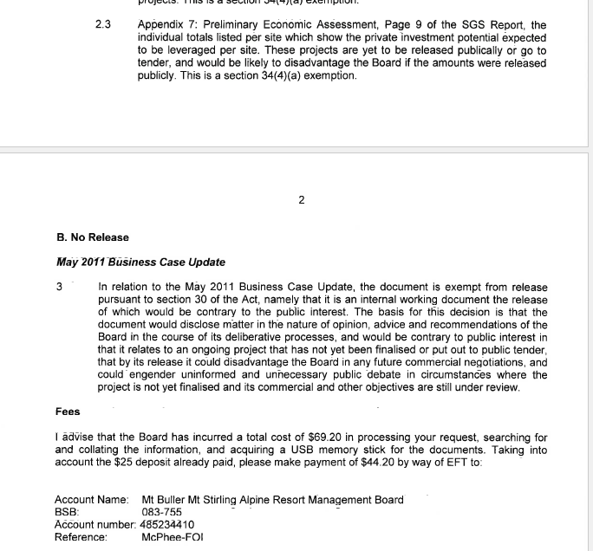

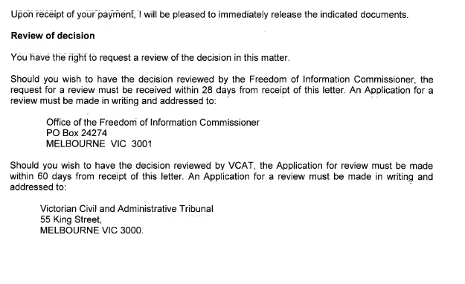

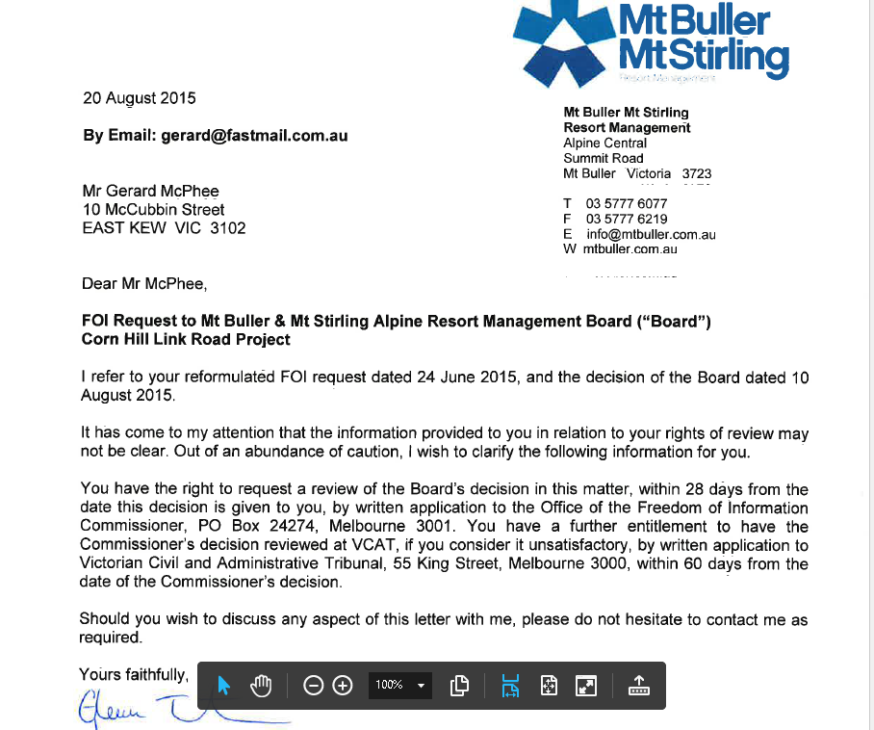

FIRST DOCUMENT SUPPLIED. SECTION 33 BASED REDACTION.
This can be downloaded from
http://gerard.com.au/Stirling/Black%20Forest%20Guest%20Spreadsheet%20redacted.pdf
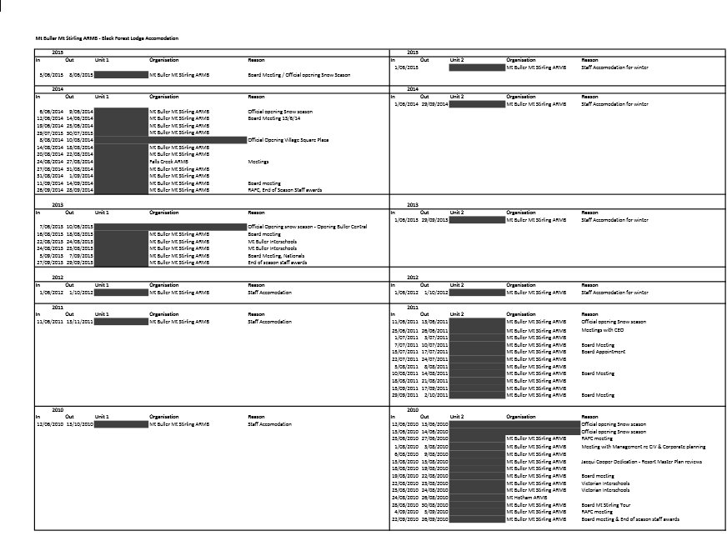

This means a government department, a local council and one of certain other bodies defined in the FOI Act.

